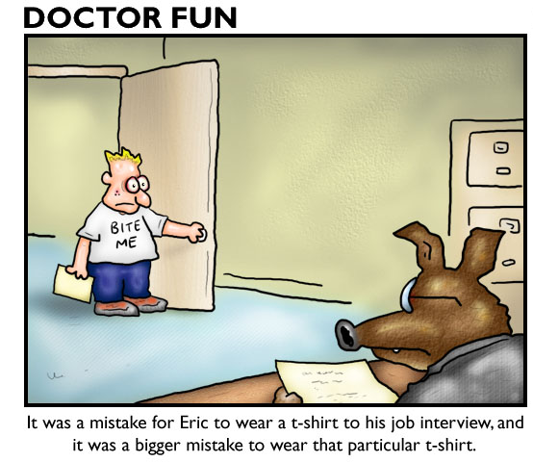
VOLUNTEER MATCHING Name_________________________________________
“Be so good that they can’t ignore you.” – Steve Martin
Part One: Questionnaire
On Monday, several representatives will be visiting from local nonprofits and organizations to recruit PSL volunteers. You will have the opportunity to interview in small groups with at least 5 of representatives. Historically, this has been a fun day that allows students to learn more about some of the assets that exist in our community. In fact, many student request to volunteer with one of the organizations that they interviewed with.
In order to make sure that you only interview with organizations where you could legitimately volunteer, please complete the questionnaire below:
- I take PSL during block (circle one): 1 2 4
- I am free or have lunch during (circle all that apply): 3a 3b 3c 3d
- I am willing to volunteer during ICE Yes No
- I have late arrival. Yes No
- I have early release Yes No
- I attend Auburn Career Center Yes No
- I am enrolled in CCP classes Yes No
  - If yes…please specify CCP schedule_________________________________________________________
- I am willing to volunteer before school. Yes No
- I am willing to volunteer immediately after school. Yes No
- I am willing to volunteer in the evenings. Yes No
- I am willing to volunteer on Saturdays. Yes No
- I am willing to volunteer on Sundays. Yes No
- I prefer to volunteer on campus. Yes No
- I have a car and am willing to volunteer off campus. Yes No
- I do not have a car but my parents can drive off campus. Yes No
- If you have a job, please tell us where you work and approximately how many hours you work per week.
___________________________________________________________________________________________
- What clubs, athletic teams, and/or community groups do you participate in?
___________________________________________________________________________________________
- Please share additional information that would help the instructors match you with a PSL partner agency.
___________________________________________________________________________________________
___________________________________________________________________________________________
___________________________________________________________________________________________
___________________________________________________________________________________________
___________________________________________________________________________________________
- Approximately how many hours did you volunteer during your junior year?

- What volunteer experience(s) do you have?

- What are your plans after high school?

- What type of job do you see yourself having 10 years from now?

- I prefer working with (circle one): people data things ideas

Part Two: Interview Planning
Based on the descriptions you heard in class today, select the five organizations you hope to interview with and rank them from 1-5 below (i.e. #1 should be the organization you are most interested in meeting, etc.). Next to each organization, briefly explain what attracted you to them.

My top 5 choices in order are: | The reason I chose this organization is:
1.

2.

3.

4.

5.

Please note, on interview day, we will do our best to schedule interviews with 3 of your top 5. Based on your questionnaire responses, we will also assign you to interview with at least two other organizations. Please keep an open mind. At the very least, this exercise will help you to hone your interview skills and learn about some of the assets that exist in our community. Some of you may even stumble upon a perfect volunteer match.
Next Steps: We will review interviewing protocols and resume writing tomorrow. Please dress appropriately for the interviews and come prepared with seven copies of your resume.

