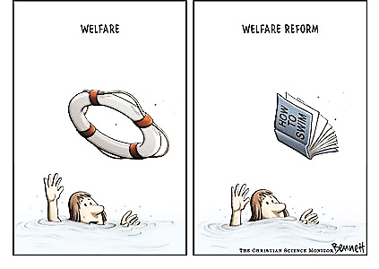
US Welfare Programs Name__________________________________________
Myths vs. Facts “I see an ADV in my future” – the anonymous PSL student
Directions: Read “US Welfare Programs, the Myths Versus the Facts” and write the answer on the line next to each description.
1._______________________ Government subsidies to the poor.
2._______________________ In 2019, a family of four needed an income below this amount in order to qualify for welfare.
3. ___________________ Number of major US welfare programs.
4. ___________________ Provides funding for welfare programs.
5. ____________________________________ Who administers America’s welfare programs?
6. ____________________________________ Eligibility for welfare programs are based on this.
7. ____________________________________ Eligibility for entitlement programs are based on prior contributions
from payroll ___________.
8. ____________________________________ Identify one of the four major U.S. entitlement programs.
9. ____________________________________ Identify the President who signed an executive order directing
federal agencies to review work requirements for welfare programs.
10. ___________________________________ This welfare program benefitted 1.2 million families in Oct. 2018.
11. ___________________________________ This President’s ’76 campaign damaged welfare’s reputation.
12. ___________________________________ TANF cut the number of families on welfare from 10 million to ___ million.
13. ___________________________________ This program paid for health care for 65 million low-income adults.
14. ___________________________________ In 2018, the avg. individual received $____ a month in food stamps.
15. ___________________________________ Acronym for the additional food stamp program for nursing mothers and children that benefitted 7.3 million people in 2017.
16. ___________________________________ This program provides cash to help the aged, blind, and disabled.
17. ___________________________________ How many people were lifted out of poverty by the EITC?
18. ___________________________________ Consists of 1.2 million units of public housing.
19. ___________________________________ True or false. Welfare recipients are unlikely to vote.
20. ___________________________________ True or false. Most undocumented immigrants are on welfare.
21. ___________________________________ True or false. Social Security is a welfare program.

