PSL SYLLABUS

Course Rationale
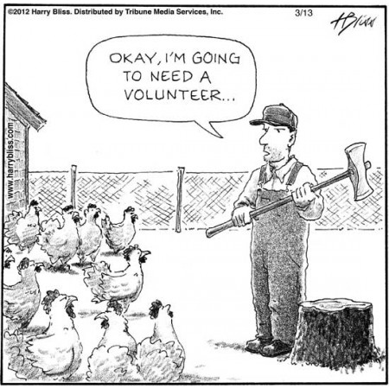
The rationale for service learning was articulated over 2,000 years ago by the Chinese philosopher Confucius who said,
“I hear and I forget. I see and I remember.
I do and I understand.”
Confucius recognized that deep learning occurs when interest is aroused by involvement. Unlike traditional classes that depend on teaching and telling in hopes that students recall information, service learning engages students in real world experiences designed to cultivate empathy and understanding. In the process, students develop informed opinions about issues confronting the people they serve and take meaningful action to address unmet needs in their community.
Service will also provide you with the satisfaction that comes from using your gifts and talents to advance something other than yourself. As Emerson once said,
“To leave the world a bit better. This is to have succeeded.”
Each year, PSL students invest thousands of hours to improve their school and community. Since 2005, PSL students – inspired by their service experiences – initiated Shantytown, the Holiday Food Drive, the Giving Garden, the student philanthropy program, and the Pirate Power Pack program. Each year, these programs collectively grant $6,000 to nonprofits, donate 5,000 lbs. of food to local pantries, and provide over 12,000 meals to Perry students. Many other PSL students have introduced projects to tackle issues confronting the elderly, people with special needs, the poor, immigrants, and the environment. How will you add to PSL’s legacy of improving the quality of life in Perry?

Course Description
Perry Service Learning (PSL) is a full year course that combines Social Studies and English curricula with meaningful service and thoughtful reflection to enhance student learning and promote civic responsibility. The service expectations involve students interacting with the people they serve (direct service), performing tasks without first-hand contact with the recipients (indirect service), and/or educating the public about issues/unmet needs in their community (advocacy). The classroom expectations are supported by a rigorous social issues curriculum that enables students to make connections between what they learn in class and experience at their service location.

Service Expectations
Students will compete for service opportunities by preparing and sharing a resume and video introduction with PSL partner organizations. Students may also have the opportunity to interview with PSL partners to determine whether or not the volunteer position matches their skills and interests. Upon receiving an offer from a PSL partner and accepting a volunteer position, students will be required to volunteer 2 hours per week with the organization.
Please note, several service opportunities are located off campus and students may need to provide their own transportation to volunteer. Moreover, the overall number of service opportunities available is limited due to the pandemic. Consequently, less than half of you will be selected for your first choice. If this poses a problem, you may want to consider alternative courses/pathways to get the credits you need for graduation.
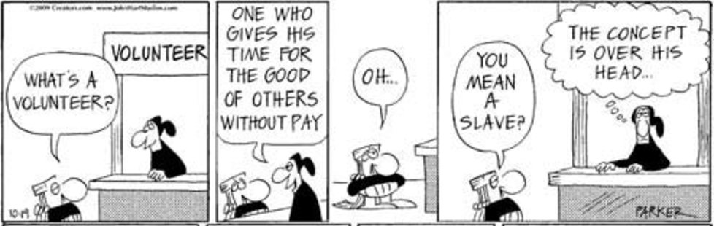
PSL students will also be required to volunteer outside of class for the 9/11 Day of Service and Remembrance, the Holiday Food Drive, MLK Day of Service, and Global Youth Service Day. Participation in these events are treated as exam grades in the gradebook.

Please note that although there will be several extra volunteer opportunities throughout the year, only the volunteer hours completed with your assigned PSL partner count towards your service grade. Students who earn extra volunteer hours will be eligible for a special recognition throughout the year (i.e. priority registration for service trips, gift cards, tshirts, scholarships, and the 100+ service hour club picnic). Extra service options may include meal prep for Project Hope, beach clean-up, river clean-ups, Shantytown, PSL Giving Garden, Perry Recreation, and many more.

Course Learning Modules
Units of study may include: Service Learning 101, Poverty & Homelessness, Philanthropy, Addiction & Recovery, Holiday Food Drive, Meaning & Purpose, Power of Relationships, Education Reform, Environmental Justice, Social Movements & Equal Protection, and Human Trafficking. In addition to the aforementioned units, opportunities for civic engagement and reflection will take place throughout the year.

Grading Policy
Please note: The Perry High School grading policy is available in the PHS Student Handbook. Service hours account for half of the academic achievement grade which represents 90% of your PSL grade. Homework and in-class assignments are considered academic practice and constitute 10% of your grade. Grades will be updated regularly under PSL English in Infinite Campus. The PSL Social Studies and Community Service grades will be entered at the
end of each term and be exactly the same at your PSL English grade.
Re-Assessment Policy: Within 7 calendar days of the student’s receipt of feedback on a summative:
- The student will create (in writing) a unique individualized plan on the re-learning steps/practice that he/she will complete before re-taking a summative assessment.
- The student will meet with the teacher and discuss the plan the student created.
- The teacher will approve the plan with any necessary additions/changes made to the plan.
- When the student has completed the plan, the student will arrange with the teacher when/how the re-take will occur. Reassessment will occur outside of school hours.

Details
- Be on time with the following items: notebook, pen, Chromebook, charger, headphones, and lawn chair.
- Respect others and their opinions.
- Do not sleep or assume the sleeping position.
- School dress code applies in school. Agency dress code applies at volunteer placement.
- The use of cell phones/electronic devices in the classroom is a privilege, as they can be a powerful educational tool. If they become a distraction, we reserve the right to prohibit their use.

Enjoy the course and take advantage of the opportunities to make your community a better place to live.
“But recognize that he who is greatest among you shall be your servant. That’s your new definition of greatness.”
—Martin Luther King, Jr.

