EDUCATION REFORM Name____________________________________
Analyzing Issues/Source Analysis “Consider the source. Don’t be a fool by
listening to a fool.” – Sylvester Stallone
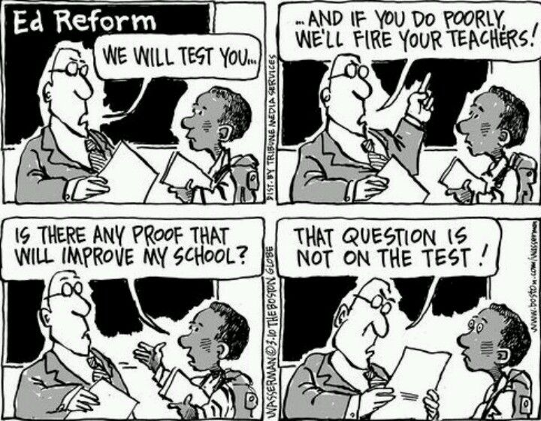
Since the creation of public education, individuals have proposed changes to alter the approach or the outcomes of schools. Recent reforms focused on standards based grading, testing, teacher evaluations, and curriculum requirements. Moreover, the pandemic sparked conversations about scheduling, personalized learning, and best practices in remote settings. This unit is designed to give you an opportunity to explore one education reform and share your opinion with leaders of the Perry Local Schools.
Choose one article from the resources provided or conduct research and find a source on your own. If you plan to write a letter with other students, each of you should review a different article. Use the media bias chart to answer questions 3-5. The other questions should be answered based on your review of the article.
P.O. | Description | Score
14 | Analyze issues through the critical use of credible sources | ____ out of 10

- What is the title of the article assigned to you?
- In what publication did this article appear? (1/2 point)
- According to the media bias chart, what is the partisan bias of this publication? (1/2 point)
Most Extreme Liberal | Hyper-Partisan Liberal | Skews  Liberal | Neutral | Skews Conservative | Hyper-Partisan Conservative | Most Extreme Conservative
- How does the media bias chart describe the overall quality of the articles found in this publication? (1/2 point)
Original Fact Reporting | Fact  Reporting | Complex Analysis | Opinion; Fair Persuasion | Selective or incomplete story | Propaganda & Misleading Info | Contains Inaccurate Info
- Using the media bias chart, what range do the stories found in this publication typically fall within? (1/2 point)
 | News | Fair interpretation of the news | Unfair interpretation of the news | Nonsense damaging to public discourse
- Who is the author of the article assigned to you? (1/2 point)
- Conduct a Google search of the author. What experience and/or qualifications does he/she have? (2 points)

- Do you consider the article to be a credible source (circle one)? (1/2 point) Yes No
- Summarize the main argument(s) found in the article in 2-3 sentences. (2 points) ___________________________
___________________________________________________________________________________________
____________________________________________________________________________________________________________________________________________________________________________________________________________________________________________________________________________________________________________________________________________________________________________
___________________________________________________________________________________________
- On the back of this paper, summarize the evidence the author provides to support this/these argument(s) in 5-7 sentences. (3 points)

