PERRY SERVICE LEARNING INVITES PARENTS TO GET INVOLVED

The PSL program is celebrating 13 years of helping students connect their living with their learning through service experiences at organizations that meet unmet needs in our community. We invite parents and guardians to support some of the many programs that PSL students will be involved with this year.

MAGNIFIED GIVING STUDENT PHILANTHROPY PROGRAM

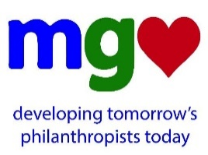
Since 2013, PSL has partnered with Magnified Giving to donate $10,000 to deserving non-profits in our community. This innovative program educates, inspires, and engages students in the art of philanthropy. Please consider making a gift to the PSL Magnified Giving fund. Your donation will not only touch the lives of students in the PSL program, but will also make its way to local non-profits where it will be used to affect many more lives.

PIRATE POWER PACK PROGRAM

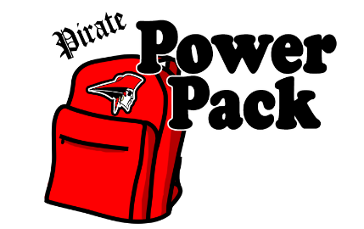
Beginning this year, PSL is partnering with The Perry Center to offer healthy meals to Perry Elementary School students who experience food insecurity over the weekends. This program provides participating students with a backpack of food for the weekend, free of charge. We are especially in need of mac & cheese, soup, individually wrapped snacks, and individual packages of cereal. Donations can be brought to the PSL room. Monetary donations are also appreciated.

PSL KITCHEN GIVES HOPE

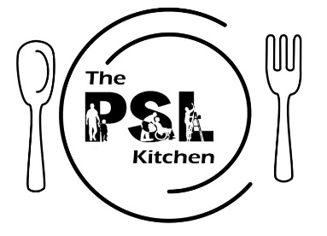
Beginning this year, PSL is partnering with Project Hope for the Homeless to provide meals for families staying at the shelter. To help make sure every belly is full each night, especially the smallest of them we are seeking donors for 15-20 family meals. Donors would arrive at the PSL kitchen at 3:00 p.m. on their assigned day, prepare a meal, and deliver it to the shelter at 5 p.m. If you would like to help in this way, please let us know below so that we can discuss the details and schedule a date.

PSL SHIRTS FOR A CAUSE ON SALE NOW

The shirts feature the PSL logo on the front and the names of each member of the PSL Class of 2018 on the back. The shirts are great to wear for most volunteer events. Proceeds benefit PSL programs (i.e. Shantytown, PHS Ability Awareness Program, Community Green Day, plunges, and field trips). If interested, please complete the order form below and submit by Friday, August 18th.

_ _ _ _ _ _ _ _ _ _ _ _ _ _ _ _ _ _ _ _ _ _ _ _ _ _ _ _ _ _ _ _ _ _ _ _ _ _ _ _ _ _ _ _ _ _ _ _ _ _ _ _ _ _ _ _ _ _ _ _ _ _ _ _ _ _

Student Name:_____________________________________ T-shirt Size (circle one): S M L XL XXL
Parent/Guardian Name:______________________________________________________________________

I/we are interested in preparing a meal in the PSL Kitchen for 15-20 people at Project Hope: Yes No
I/we would like to make a gift of (check all that apply)
DUE FRIDAY, AUGUST 18TH

THANK YOU!
- $15 for a PSL t-shirt
- $25 to support the Magnified Giving program
- $35 to support a student in the Pirate Power Pack program for 5 weeks
- $50 to buy groceries to make a meal for 15-20 guests at Project Hope

Total: $__________ (Please make check payable to Perry High School)

