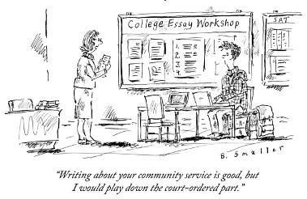
UNDERSTANDING THE PSL SERVICE HOUR RUBRIC
PSL volunteers are required to log their service hours weekly using InnerView. Each service hour claim is verified by your PSL teacher and supervisor.
InnerView creates a service resume that you may share with teachers who write recommendation letters for you, may qualify you for a national service award, and will be used by an alumni panel to determine the winners of PSL Art Buser Memorial Scholarship and PSL Alumni Scholarship.
Directions: Using the PSL service hour rubric, assess the timesheets submitted by former PSL students.
__________________________________________________________________________________________________
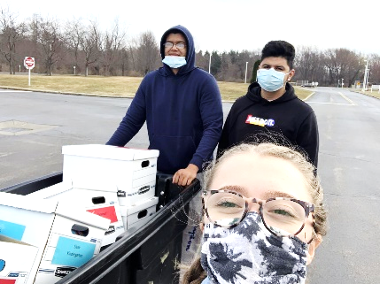
Activity Title: Pirate Power Packs
Service Hours Claimed: 2 hours
Global Goal: #2 Zero Hunger
Description: My fellow volunteers and I delivered 25 power packs to various teachers in the Elementary School to feed their students over the weekend. We also picked up empty boxes from 16 classrooms so we could bring them back to the Power Pack room to supply students with food for next week. Afterwards we picked up 10 cases of canned food from the Perry Center to stock the pantry and vacuumed the Power Pack room so our work place is clean. Our job was important because people don't deserve to be hungry and we helped to solve that this weekend!
Example 1: ______/20
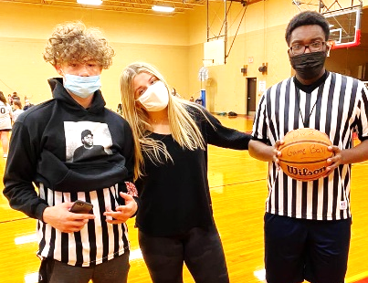
_________________________________________________________________________________________________
Activity Title: Perry recreation
Service Hours Claimed: 2 hours
Global Goal: #3 Good Health & Well-Being
Description: Volunteered as a Referee for Perry Rec basketball
Example 2: ______/20 __________________________________________________________________________________________________
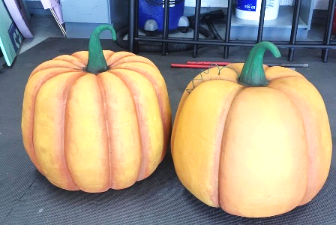
Activity Title: Footprints Center for Autism
Service Hours Claimed: 2 hours
Global Goal: #4 Quality Education
Description: This week I attended the preschool Halloween party. I was able to work with a student on painting a styrofoam pumpkin. The student I was working with, and other students, took turns painting the pumpkin with brushes and even with there fingers. We had fun all class doing different crafts and playing with different toys.
Example 3: ______/20
__________________________________________________________________________________________________
Instructions for Adding 9/11 Day of Service and Remembrance Activities
- To add a service activity, click the “+” symbol in the blue circle on the bottom right.
- Enter the Activity Title.
- Enter the Date of the activity.
- Enter the Hours for the activity. For simplicity, it is recommended that you round to the nearest quarter hour. Therefore, your hours should end with .00, .25, .50, or .75.
- Select an Activity Type that describes the service from the list provided.
- Under Value select either compassion, connectedness, curiosity, integrity, respect, or spirituality.
- Under Impact select the Sustainable Development Goal (SDG) that best aligns with the activity.
- Your Description is the most important component. It must be written in complete sentences. It should answer who, what, where, and why. It should also describe the impact of your service in terms that are measurable. Failure to do all of the above will result in partial or no credit.
- Include a Photo from the activity that complies the policies of the organization you served.
- Under Did you do this with a group? Select PSL.
Supervisor name, email, and phone number: Mr. Soeder, soederm@perry-lake.org, 440-840-5066
__________________________________________________________________________________________________
Activity Title: Perry Township Beach Clean-Up
Service Hours Claimed: 1 hour
Global Goal: #6 Clean Water & Sanitation
Description: Worked alongside 29 classmates to remove litter and debris from Perry Township Beach. Collectively filled fifteen 13-gallon trash bags with plastic, styrofoam, metal, dead fish, and other objects that had washed up on shore. Also discarded one old tire and two tire rims that were polluting the beach. As a result of our efforts to remove these contaminants, the beach will be safer for visitors and wildlife.
Activity Title: American Legion Cemetery Flag Removal
Service Hours Claimed: 1 hour
Global Goal: #16 Peace, Justice, and Strong Institutions
Description: Worked alongside 29 classmates and 10 members of the American Legion Post to remove over 1,000 flags from the graves of veterans at Perry Center. Sorted flags to determine which needed to be retired and which could be reused next year. This opportunity allowed my classmates and I to honor local veterans, both living and deceased, and served as a way for us to thank them for their service.
Activity Title: SADD Veteran Drive-Thru Lunch
Service Hours Claimed: 1 hour
Global Goal: #16 Peace, Justice, and Strong Institutions
Description: Worked alongside 8 classmates to prepare and serve meals to 63 veterans and first responders in our community. This event was planned and coordinated by students in SADD in honor local heroes for 9/11 Day of Service and Remembrance. Volunteers served sub sandwiches, chili, chips, and water to each veteran/first responder. Although the veterans were grateful for the meal, they were even more thankful for the actions of all students involved.
Activity Title: Giving Garden Potato Harvest & Container Recylcing
Service Hours Claimed: 1 hour
Global Goal: #2 Zero Hunger
Description: Block 4 PSL students teamed up with 30 third graders to harvest 55 pounds of potatoes for The Perry Center from the PHS Giving Garden, while some volunteers sterilized 200+ potting containers for the Holden Arboretum. This activity assisted a local nonprofit by providing fresh produce to a food bank that typically distributes processed foods. It also saved another nonprofit hundreds of dollars by allowing them to recycle potting containers.
AFTER ADDING SERVICE ACTIVITY COMPLETED ON 9/10, CREATE A SEPARTE TIME SHEET FOR PSL SERVICE YOU DID THIS WEEK.

