PSL NOTEBOOK CHECK Name_____________________________________________
5th Grading Period “Unless it’s committed to paper, you can lose an idea forever”
– the anonymous PSL student
CLASS NOTES AND DAILY ACTIVITIES

Points | Date | Description
____/5 | 2/26 | Art as Argument: OPTIC Analysis
____/5 | 2/28 | Class notes on Illegal Immigrants
____/5 | 3/7 | Topics in Immigration Reform: Presentation Notes (Border Security, DACA, Refugees)
____/5 | 3/14 | Topics in Immigration Reform: Presentation Notes (Deportation, Economics, Sanctuary Cities)
____/5 | 3/23 | Class notes on Social Movements
____/5 | 4/4 | Viewing notes on Including Samuel
____/5 | 4/6 | Class notes on Disability Rights Movement
____/5 | 4/9 | Class notes on Accommodations, Assistive Technology, and Adaptive Equipment
____/5 | 4/16 | Class notes on Environmental Justice
____/45 | TOTAL

READING NOTES

Points | Date | Description
____/5 | 1/12 | Reading notes on The Prologue of Enrique’s Journey
____/5 | 1/19 | Reading notes on Chapter One of Enrique’s Journey
____/10 | TOTAL

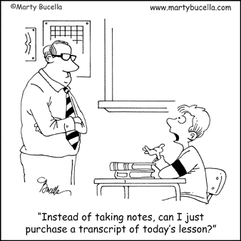
TOTAL: _____ /55

