PSL NOTEBOOK CHECK Name_____________________________________________
4th Grading Period “Unless it’s committed to paper, you can lose an idea forever”
– the anonymous PSL student
CLASS NOTES AND DAILY ACTIVITIES

Points | Date | Description
____/5 | 1/10 | The Power of Relationships: Learning Targets, “The Little Boy & The Old Man”
____/5 | 1/17 | Essential Questions; Resources; New Stuff
____/5 | 1/29 | The Memory Project: Causes; Individual/Systemic; Problem; Solutions; Individual/Systemic
____/5 | 1/31 | Intergenerational Interviews: Developing Interview Questions (3-5 questions for each topic)
____/5 | 2/21 | Immigration: Refugees; Sources; Hosting Countries; U.S. Resettlement Program; Trump/Warren
____/25 | TOTAL

READING NOTES

Points | Date | Description
____/5 | 1/12 | Reading notes on pp. 1-68 of Tuesdays with Morrie
____/5 | 1/19 | Reading notes on pp. 69-129 of Tuesdays with Morrie
____/5 | 1/22 | Reading notes on pp. 130-199 of Tuesdays with Morrie
____/15 | TOTAL

REFLECTIONS

Points | Date | Description
____/10 | 1/22 | Service reflection #8: How does Tuesdays With Morrie help you answer the question "What happens when we choose to invest time in others?" Draw specific connections between the text and your service experiences.
____/10 | TOTAL
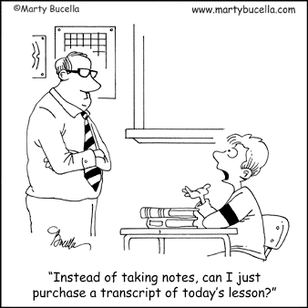
TOTAL: _____ /50

