ASSESSING SOURCES Name_______________________________________________
Political Bias Evaluation “I wish I had PSL 7 days per week.” – anonymous PSL student
PO# | Objective | Score
1 | Read and comprehend complex informational texts.
14 | Analyze issues through the critical use of credible sources.

Directions: Answer the following questions about the article assigned to you in class.
Title:
Source:
- According to the media bias chart, where do articles in this publication typically fall on the political spectrum?

- According to the X axis of the media bias chart, how is the overall content quality of this publication categorized?

- According to the Key of the media bias chart, what rectangle does this publication fit in? What is the meaning of that rectangle?

Author:
Conduct a Google search for the author(s).
- What else have they published on this topic?

- Are there any credentials that establish the author as an expert or reliable source?

Read the article. List all examples you can find for each form of bias, along with a quote or other evidence that shows bias is there.
- Bias by headline:

- Bias by word choice or tone:

- Bias by selection and/or omission:

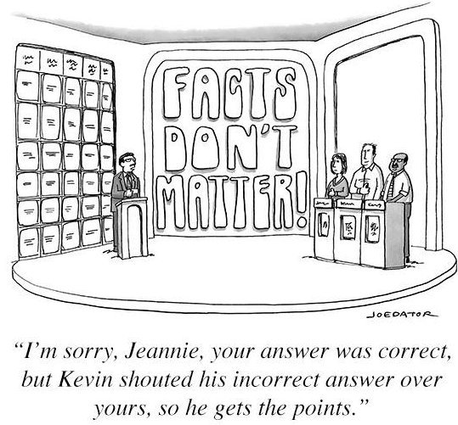
- Bias by labeling or title:

- Bias by photos, captions, or camera angles:

- Bias by statistics:

