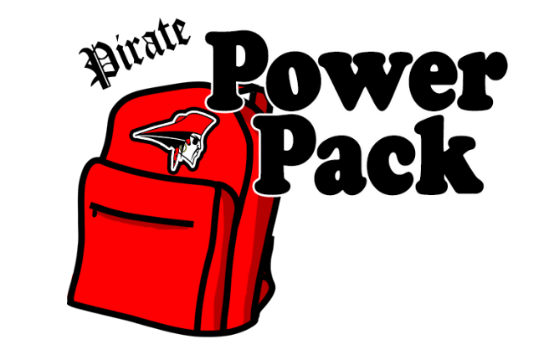

WISH LIST
Thank you for supporting the Pirate Power Pack program at Perry Elementary School that provides nutritious meals to students who may otherwise experience food insecurity over the weekend. The following items are needed:

Apple sauce (single serve cups)
Apples
Bananas
Cereal (single serve boxes, cups, or bags)
Chef Boyardee (microwavable cups or easy-open cans)
Fruit cups (single serve cups)
Granola bars
Instant oatmeal (single serve packets)
Jelly (single serve packets)
Jif To Go Creamy Peanut Butter (1.5 oz. cups)
Macaroni and cheese
Microwave popcorn
Pop-Tarts
Pudding cups (single serve cups)
Raisins (single serve 1 oz. packages)
Rice Krispies (single serve packets)
Single serve snacks
Soup
Trail mix (single serve packs)
V8 splash (5.5 oz. cans)

Donations can be dropped off at the Perry Service Learning Center for Civic Engagement located at 4261 Manchester Road, Perry, Ohio 44081. Please contact Mark Soeder (soederm@perry-lake.org) or Allison Trentanelli trentanelli@perry-lake.org) to schedule a delivery.

