Your child is receiving this free bag of food through the
PIRATE POWER PACK PROGRAM
The Perry Center and Perry Service Learning Program are teaming up with Perry Elementary School to offer a supply of nutritious meals and snacks for children over their weekends and extended breaks, free of charge. Since food and nutrition are so closely linked with the ability to learn, we want to make sure students have nutritious meals over the weekend so they are ready to learn when they arrive at school on Monday. For this reason, the Pirate Power Pack program was created. Their teacher distributes bags to your child on the last school day before the weekend or break. Any child enrolled in Perry Elementary School is able to receive these weekly bags of food.
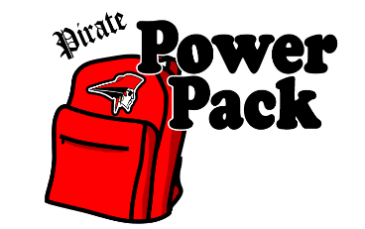
This bag is a sample of what your child will receive by participating in the Pirate Power Pack Program. If you believe your child could continue benefiting from this program, we will continue providing this resource to your child each week until they leave the school or until you no longer wish to participate. If you do not want your child to continue with this program, please fill out the form below. You only need to return this form if you do not want your child to participate in the program.
We encourage you to take advantage of this program for your family and your children.
Questions or concerns, please Mark Soeder at soederm@perry-lake.org or
Allison Trentanelli at trentanellia@perry-lake.org or call 440-259-9200 x9708
--------------------------------------------------------------------------------------------------------------------------------------------------
Pirate Power Pack Opt-Out Form
Please remove my child(ren) from the Pirate Power Pack program. I understand my child(ren) will no longer receive a supply of food at the end of each week for his/her use over the weekend or school holiday. Please print clearly.
Today’s date:_____________________________________
Child’s name, teacher, and grade:______________________________________________________________________
Child’s name, teacher, and grade:______________________________________________________________________
Child’s name, teacher, and grade:______________________________________________________________________
Child’s name, teacher, and grade:______________________________________________________________________
Child’s name, teacher, and grade:______________________________________________________________________
Parent/Guardian Name:______________________________________________________________________________
Parent/Guardian Signature:___________________________________________________________________________
If you would like to participate in the future, please contact your school’s front office.
Thank you for considering the Pirate Power Pack program.

