Free Weekend Food For Your Child Available Through
PIRATE POWER PACK PROGRAM
Your child and his/her nutrition and education are a priority at the Perry Local Schools. We want to make sure your child has the tools necessary to succeed in the classroom. We are partnering with the Perry Center and Perry Service Learning program to offer healthy meals for our students over the weekend for the 2017-18 school year.
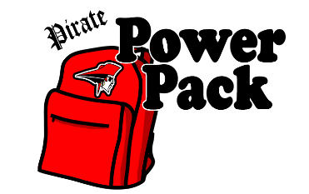
Since food and nutrition are so closely linked with the ability to learn, we want to make sure students have nutritious meals over the weekend so they are ready to learn when they arrive at school on Monday. For this reason, the Pirate Power Pack program was created. This program provides participating students with a small bag of food for the weekend, free of charge. This program is confidential and bags will be distributed discreetly by teachers on the last day of school before weekends and extended breaks.
If you believe your child could benefit from this program, we encourage you to sign them up by filling the form out below and returning it to the Perry Elementary School office. This is a year-long program that children can enroll in at any time. Once your child is signed up, they will receive bags of food each week until they leave the school or until you no longer wish to participate.
We encourage you to take advantage of this program for your family and your children.
Questions or concerns, please contact Mark Soeder at soederm@perry-lake.org or
Allison Trentanelli at trentanellia@perry-lake.org or call 440-259-9200 x9708
----------------------------------------------------------------------------------------------------------------------------------------------------------------
Pirate Power Pack Consent Form
By signing below, I give permission for my child to participate in the Pirate Power Pack program. I recognize that there is no cost to participate in the program and will use the food in the best interest of my child. Please print clearly.
Child’s name___________________________________________ Child’s Teacher________________________________
Special dietary needs, if any (e.g. diabetic, food allergy, etc.):_________________________________________________
Parent/Guardian Name______________________________________________________
Parent/Guardian Signature____________________________________________________ Date____________________

Optional: Whether or not your child will be participating in the Pirate Power Pack program, we welcome your support. Please check any box below, according to your interest(s).
- I may be interested in helping to pack food bags.
- I may be interested in serving as a volunteer with the Pirate Power Pack program.
- I may be interested in donating to or financially supporting the Pirate Power Pack program.
Parent/Guardian name:______________________________________ Phone number:____________________________
Parent/Guardian email address (if any): __________________________________________________________________
Please return to the Perry Elementary School office

