Perry Service Learning Program Name: __________________________________________
It’s a Wonderful Life – Legacy

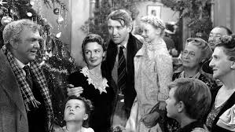
Frank Capra’s 1946 film It’s a Wonderful Life illustrates the capacity one individual has to make a difference in the community by sharing the experiences of George Bailey and the town of Bedford Falls.
As you watch the film, explore the legacy George leaves his community and his family, as well as the legacies of his wife, Mary, and his friend, Clarence. After watching the films, reflect on each character’s legacy, and connect those discoveries with your service experiences in PSL.

While watching the film…
What is George Bailey’s legacy?

Identify one quote or aphorism that George says which helps reveal his legacy.

What is Mary Hatch Bailey’s legacy?

Identify one quote or aphorism that Mary says which helps reveal her legacy.

What is Clarence’s legacy?

Identify one quote or aphorism that Clarence says which helps reveal his legacy.

After watching the film…

Which character do you most identify with? Why?

How does the movie relate to your service experience(s)?

How does this movie relate to the Perry Service Learning Program?

