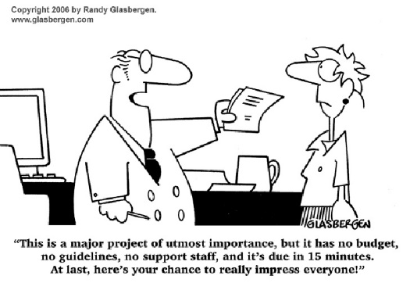
Essential Questions
What makes an “inclusive community?”
How can we use our time, talent and treasure to become a more inclusive community?
Goal
Research/design/fund a project that will make Perry a more inclusive community.
Option A: Collaboratively research, design, and help fund an accessible playground at the Outdoor YMCA. If interested in this project, some funding has been secured, and there is an existing collaboration between PSL, the Outdoor YMCA, and Camp Sue Osborn.
Option B: Create your own project. Complete a needs assessment, researching the areas where Perry can be more inclusive. Design a strategic plan outlining the necessary steps. Implement a fundraiser to support your efforts.

Rubric
Proficient | In Progress | Not Met
The proposal addresses the issue of discrimination against people with special needs, and engages others to advocate for the expansion of the rights of this group. | The proposal attempts to address the issue of discrimination against people with special needs, and engages others to advocate for the expansion of the rights of this group. | The proposal does not address the issue of discrimination against people with special needs, and does not engage others to advocate for the expansion of the rights of this group.
The proposal demonstrates student engagement in activities that meet community needs. | The proposal attempts to demonstrate student engagement in activities that meet community needs. | The proposal does not demonstrate student engagement in activities that meet community needs.
The proposal demonstrates the ability to conduct a short research project to solve a problem. | The proposal attempts to demonstrate the ability to conduct a short research project to solve a problem. | The proposal does not demonstrate the ability to conduct short research to solve a problem.
The proposal demonstrates clear and coherent writing in which the development, organization, and style are appropriate to task, purpose, and audience. | The proposal attempts to demonstrate clear and coherent writing in which the development, organization, and style are appropriate to task, purpose, and audience. | The proposal does not demonstrate clear and coherent writing in which the development, organization, and style are appropriate to task, purpose, and audience.

Proposal Elements
Project Narrative: What are the goal(s) of the project? Why is this project important/necessary/relevant? What do you hope to achieve through the project? What needs will this project address?
Research: What research have you done in support of this project?
Community Partnerships: What organizations can you/will you partner with to effectively implement this project? How will this project engage a variety of community members?
Funding Recommendation: What funding should be pursued to support the project?
Project Timeline
Friday, April 6th – Introduce Inclusive Communities Project Proposal and determine project/collaborators. Conduct introductory research to begin developing project narrative. Exit Slip: In a Google doc, document project option, collaborators, and emerging narrative. Share with Mrs. Trentanelli prior to the end of the block.
Monday, April 9th – Revise narrative, and begin developing research, community partnership, and funding recommendation elements in class. Exit Slip: Share Google doc, documenting revisions/addition to all elements of the project proposal. Mrs. Trentanelli will provided feedback by Tuesday afternoon.
Wednesday, April 11th –
Block 1 (7:30am-9:00am) and Block 2 (9:30am-11:00am) - Visit the Miracle League adaptive playground in Eastlake. Breakfast provided. No exit slip required today.
Block 6 students – Engage with speaker on inclusion in the PSL classroom.
Friday, April 13th –
Block 1 and 2 – Engage with speaker(s) on inclusion in the PSL classroom.
Block 6 (1:30pm-3:00pm) - Visit the Miracle League adaptive playground in Eastlake. Snacks provided. No exit slip required today.
Monday, April 16th – Thursday, April 19th – Using feedback, revise/complete proposal and share final draft with Mrs. Trentanelli by 12noon on Thursday, April 19th.
FAQ’s
Can more than one group choose Option A?
Absolutely! The more creative people who working to address this project, the more successful we will be.
Do we have to go on the field trip even if we choose Option B?
Yes! Why wouldn’t you want to go to a playground?
What should the proposal “look” like?
That is up to you. I shared the elements I want to see, and outlined the rubric areas I will be assessing. As long as you address those, you are free to design a proposal that is professional, polished, and creative.

