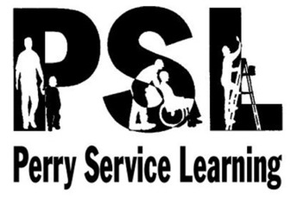
PSL FIELD TRIP
PERMISSION FORM
The PSL classes will travel to Wickliffe High School on Monday, October 30th to meet Roger Grein, a self-made millionaire and founder of Magnified Giving, who will discuss how to become engaged in your community through philanthropy. In 2012, Grein was named the Philanthropist of the Year by the Association of Fundraising Professionals. He has given away more than $7 million to charities and over the last 20 years.
Transportation will be provided by school bus. Bus pick up and drop off times are as follows:
Block 1: Depart PSL classroom at 8:50 a.m./Return to PSL classroom at 11:09
Blocks 2 & 6: Depart PHS bus loop at 9:00 a.m./Return to PHS bus loop at 11:05
If you have any questions, feel free to call Perry High School at 440-259-9300. In the event that you need to contact us while we are on the trip, you may call 440-823-1501.
Thanks,
Mr. Soeder and Mrs. Trentanelli

----------------------------------------------------------------TEAR HERE--------------------------------------------------------------------

PERRY HIGH SCHOOL
FIELD TRIP PERMISSION FORM

Monday, October 30, 2017 ____Mr. Soeder & Mrs. Trentanelli_______
Date of Trip Teachers/Faculty Members in Charge

I have read the above information and my signature below indicates my son/daughter has my permission to leave on this trip, be transported in the manner described and I understand the information given.
Students will not be permitted to participate unless their parent/guardian has complete an annual update/ Emergency Medical Authorization (EMA) form in Infinite Campus.

_____________________________ ___________________________________
Name of Student Signature of Parent/Guardian

