GLOBAL GOALS Name____________________________________
Anticipation Guide This assignment is not oppressive. In fact, I like it.” -- the anonymous PSL student

Directions: Read each statement below and predict whether it is true or false.
- The 85 richest people in the world have as much wealth as the poorest half of all humanity, 3.5 billion people. | True | False
- In the USA, the average worth of white households in 20019 was 113,149 compared to African American households at $5,677 and Hispanic households at $6,325. | True | False
- 80% of people with disabilities live in less developed countries. | True | False
- In most developed countries the unemployment rate for people with disabilities is at least twice that for those who have no disability. | True | False
- In Latin America 80-90% of persons with disabilities are unemployed or outside the work force. Most of those who have jobs receive little or no pay. | True | False
- By 2040, it is estimated that over 25% of Europeans are expected to be at least 65 years old. | True | False
- In the UK the unemployment rate for people aged 16-24 is 14.4%. The overall unemployment rate is 5.7%. | True | False
- Globally, women occupy less than 25% of all seats in parliament. | True | False
- In the UK twice as many women as men rely on state benefits. | True | False
- In the UK two thirds of retirees living in poverty are women. | True | False
- In Europe, easy access to green spaces improves the health of poorer people by as much as 40%. | True | False
- In the USA, people living close to public transportation can access up to three times as many jobs. | True | False

Obj. | Description | Score
6 | Initiate and participate in collaborative discussions | A P IP NM
9 | Identify causes of oppression against minority groups and analyze proposed solutions. | A P IP NM

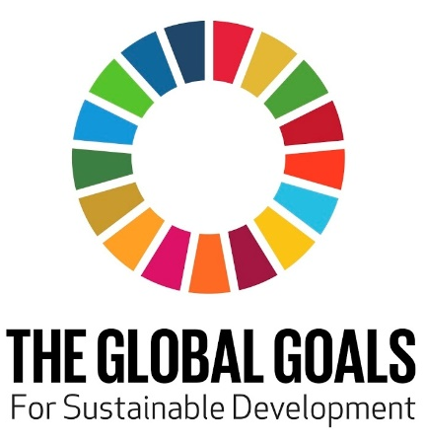

SCORE FOR TEACHER USE ONLY

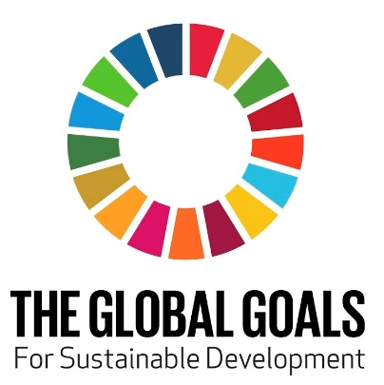
Vocabulary: Write the definitions of the terms listed below.
Inequality:
Sustainable Development Goals:
Humanitarian:

STATION 1: SUNSHINE ROOM
Write the number of the sustainable development goal that the photo represents.
Photo #1: _____ Photo #6: _____
Photo #2: _____ Photo #7: _____
Photo #3: _____ Photo #8: _____
Photo #4: _____ Photo #9: _____
Photo #5: _____
STATION 2: ROCKING CHAIR ROOM
View the video and answer the following questions:
- The UN hopes to achieve the global goals by what year? ___________________________.
- There are three ways you can help: invent, innovate, and _________________________.
- Young people are changing the world for good. And so can you. You just need to care, get creative, and _______________________.
STATION 3: POWER PACK ROOM
Write the number of the sustainable development goal that the PSL program attempts to address.
_____ Captain’s Closet
_____ Magnified Giving Student Philanthropy

_____ Pirate Power Packs
_____ PSL Giving Garden
_____ PSL Green Team (Recycling Program)
_____ PSL Kitchen
_____ Seniors Helping Seniors
_____ Thriving Threads Clothing Room
STATION 4: MAGNIFIED GIVING ROOM
Write the number of the sustainable development goal that the quote represents.
Quote #1: _____ Quote #4: _____
Quote #2: _____ Quote #5: _____
Quote #3: _____ Quote #6: _____
STATION 5: LIBRARY
Review portfolios and write the name of the partner agency that addresses the Global Goal listed below:
Global Goal #1: _______________________________
Global Goal #2: _______________________________
Global Goal #3: _______________________________
Global Goal #4: _______________________________
Global Goal #10: ______________________________

STATION 6: MAIN CLASSROOM
On your own, come up with a new PSL program that could address the global goal that is most important to you.
1. What is the name of the new program?
2. What global goal would this new program address?
3. Provide a 3-5 sentence description of the new program and how it would work (use margins and back side)

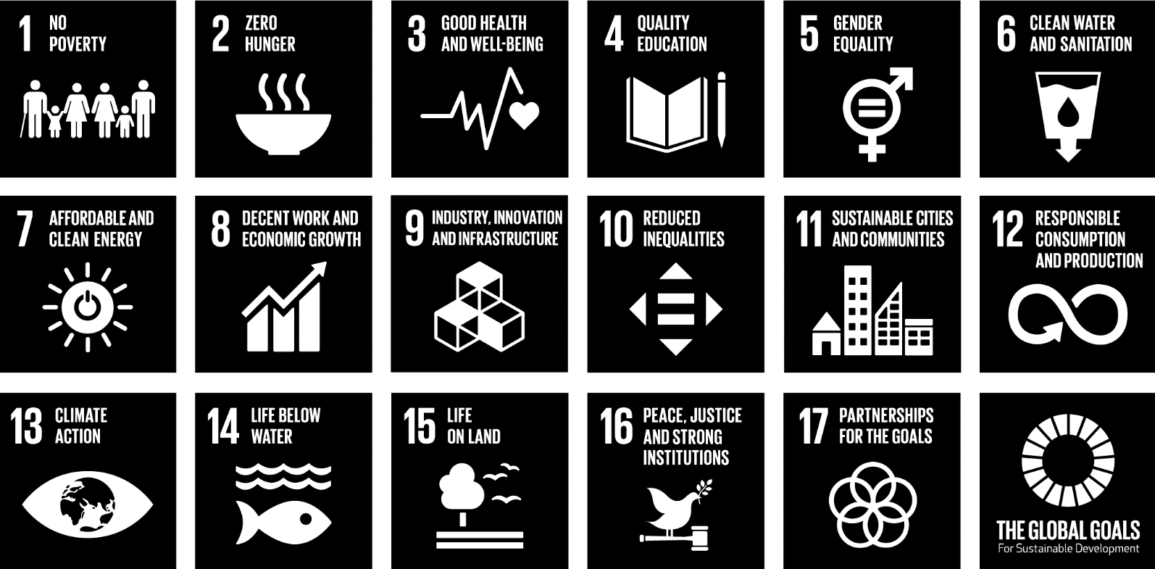
Goal 1 - End poverty in all its forms everywhere
Goal 2 - End hunger and ensure everyone has access to healthy and nutritious food
Goal 3 - Ensure healthy lives and promote well-being for all at all ages
Goal 4 - Ensure inclusive and good education for all people
Goal 5 - Achieve gender equality and empower all women and girls
Goal 6 - Make sure everyone has access to safe and clean water
Goal 7 - Make sure everyone has access to safe and clean energy
Goal 8 - Promote inclusive and sustainable economic growth so that everyone is able to have decent work prospects
Goal 9 - Build resilient infrastructure and ensure these do not harm the environment or people, and help companies to design and create new technologies and innovations
Goal 10 - Reduce inequality within and among countries
Goal 11 - Make cities and human settlements inclusive, safe, resilient and sustainable
Goal 12 - Ensure sustainable consumption and help to stop food waste
Goal 13 - Take urgent action to combat climate change and its impacts
Goal 14 - Conserve and protect the oceans and marine life
Goal 15 - Protect, restore and promote nature and the animals that live in it
Goal 16 - Promote peaceful and inclusive societies for sustainable development, provide access to justice for all and build effective, accountable and inclusive institutions at all levels
Goal 17 - Create new partnerships around the world for the Global Goals

