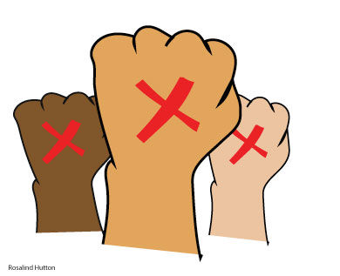
END IT: INDIFFERENCE IS NOT AN OPTION Name___________________________________________
Viewing Guide “You may choose to look the other way but you may never
say again that you did not know.” -anonymous PSL student
Directions: Fill in the blanks or circle the correct answer while watching the stories of three former slaves who have been rescued and now have freedom.
INTRODUCTION
- SLAVERY: When one person is controlled by another, ___________________ to work against their will and treated like property.

- True or False. There are more people enslaved today than during the entire African slave trade.
- Meena was enslaved for two years. What country was she from?
a.) Myanmar b.) Cambodia c.) Bhutan d) Nepal
4. Raman was born and bonded into slavery. What country was he from?
a.) Bangladesh b.) Pakistan c.) Sri Lanka d.) India
5. Katya was forced into sex slavery in this country:
a.) Greece b.) Turkey c.) Corsica d.) Malta
DESPAIR WHEN HOPE IS LOST
6. Katya, Raman, and Meena were all
a.) trapped b.) content c.) hardworking d.) protected
BEGINNINGS: HOW DID THIS HAPPEN?
7. Unable to find a job in Russia, Katya found a newspaper ad looking for ____ to work in other countries.
a.) housekeepers b.) waitresses c.) nannies d.) nurses
8. Raman started working at the rice mill when he was ____ years old.
a.) 9 b.) 12 c.) 15 d.) 18
9. What prompted Meena to seek work in another country?
a.) Her parents died b.) She lost her job c.) Her husband left her d.) natural disaster
REDEMPTION: MAKING BROKEN THINGS NEW
10. How did Katya escape?
a.) by taxi b.) by plane c.) by boat d.) by train
11. What was the name of the organization that helped free Raman?
a.) the United Nations b.) Amnesty International c.) IJM d.) WHO
12. What did Meena use to escape?
a.) shawls b.) rope c.) ladder d.) bed sheets
CONCLUSION
13. We need to stop listening to statistics and start __________________________ them.
FOR TEACHER USE ONLY
PO# | Description | Score
9 | Identify causes of oppression and analyze proposed solutions. | ADV P IP NM

