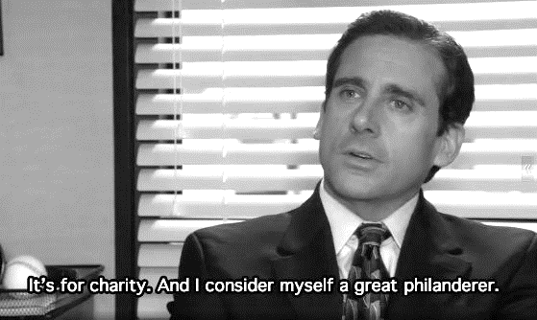
PSL ANNUAL FUND CAMPAIGN
​As Thanksgiving approaches it seems appropriate that we pause and thank the organizations that provide us with meaningful service opportunities Furthermore, it is a good time to seek the support of the community that we serve. Each year PSL program facilitates programs that invest thousands of dollars into meeting unmet needs in our region. Annual expenses PSL programs will total $13,597 this year.
WE NEED YOUR HELP
Each PSL student will send 10 emails (8 to PHS alumni and 2 to family members of your choice) during today's class in an effort to secure donations to the annual fund. This represents a summative exam grade for objective #7 (Demonstrate command of standard English when writing) and #15 (Contribute to the Common Good Through Various Channels).
Check your email for alumni you are assigned to contact. Then follow these steps before copying the message below:
- Do NOT send a group message to all of the alumni that you are responsible for. Emails with multiple addresses are more likely to get flagged by spam filters.
- Your subject line should read: Perry High School - Make a Gift. Make a Difference.
- Carbon copy (Cc:) soederm@perry-lake.org and trentanellia@perry-lake.org on every message.
- Personalize EVERY salutation: (i.e. Dear Mr. Smith or Dear Ms. Smith) followed by a comma.
Dear ____________,
I am currently a senior at Perry High School participating in the Perry Service Learning (PSL) program. Despite the pandemic, PSL students have already participated in over 900 service activities totaling 1,900 hours of service since August. In the weeks ahead students will:
- participate in Shantytown, an overnight event to raise awareness about homelessness in our community;
- award $2,000 to deserving nonprofits in our community;
- conducts a holiday food drive generating over $2,000 and 4,000 lbs. of food for The Perry Center;
- maintain the Giving Garden at Perry High School generating 300 lbs. of produce for The Perry Center;
- provide 210 meals every weekend for students experiencing food insecurity through Pirate Power Packs.
Your help is what makes these community service initiatives possible. The annual fund generates revenue that enables PSL to continue these programs and provide meaningful service opportunities for students like me. Our goal is to raise $15,000 to help us continue to build a culture of service at Perry High School. You can make your gift today at https://fundly.com/perry-service-learning-annual-fund-1. If you prefer, mail a check made payable to "Perry High School" to:
Perry Service Learning
Perry High School
1 Success Boulevard
Perry, Ohio 44081
Thank you in advance for making a gift and making a difference. If you have any questions, please contact my teachers Mr. Soeder (soederm@perry-lake.org) or Mrs. Trentanelli (trentanelli@perry-lake.org).
Sincerely,
Joe Smith, Class of 2021
WHAT’S IN IT FOR YOU?
In addition to serving as a summative assessment covering two course objectives, at least one-fourth of the money generated from the email campaign will be used to establish a scholarship fund exclusively for PSL students. The best part is that NO SEPARATE SCHOLARSHIP APPLICATION WILL BE REQUIRED. Instead, a panel of PSL alumni will be reviewing the InnerView logs of each student in PSL and determine the winner(s) based on hours served, diversity of activities, description of activities, and demonstrated leadership. Every PSL student is eligible regardless of their post secondary plans. AS A SPECIAL BONUS, THE 5 STUDENTS WHOSE EMAILS NET THE MOST DONATIONS WILL RECEIVE A $20 GIFT CARD TO THE ESTABLISHMENT OF THEIR CHOICE.

