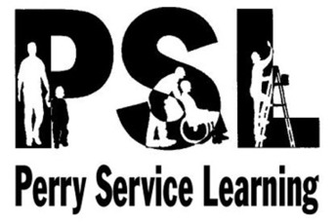
SERVICE LEARNING 101 EXAM
STUDY GUIDE
The exam will consist of:
- 14 identification questions
- 6 short answer questions related to the PSL survival manual
- 5 questions regarding professional communication
- 5 multiple choice questions related to Global Goals #1-#17
- 10 multiple choice questions regarding volunteer professionalism
- 10 questions regarding professional dress
Terms
There will NOT be a word bank on the exam. That said, you should be prepared to define, identify, and/or provide an example for the following terms:

- Direct service
- Indirect service
- Advocacy
- Community service
- Service learning
- Internship
- Inequality
- Sustainable Development Goals
- Charity
- International Day of Charity
- Empathy
- Helping Serving
- Confidentiality
- Civility

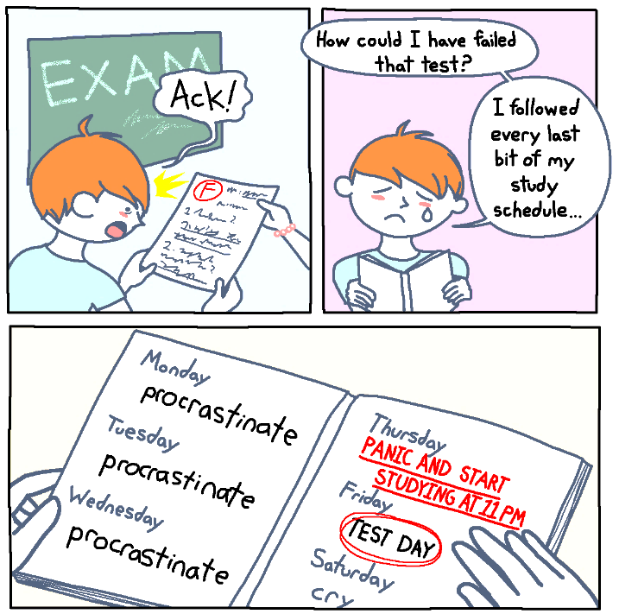
Resources to study
Class notes on:
- Distinguishing Among Service Programs
- Global Goals
- Volunteer Professionalism
Although you may NOT use them on the exam, it would be wise to study the following items
- “Service-Learning: A Balanced Approach to Experiential Education” by Andrew Furco
- Developing a Definition for Service Learning Quiz
- Global Goals Learning Station Rotation assignment
- PSL Survival Manual

Power Objectives:
#7 Demonstrate command of conventions of standard English when writing and/or speaking
#13 Identify and explain roles that citizens in a democracy can play to address community needs.
#19 Develop a vision for success in your volunteer placement.

