IMMIGRATION REFORM Name__________________________________
Part One: Considering Immigration Issues from Multiple Perspectives
Define oppression:

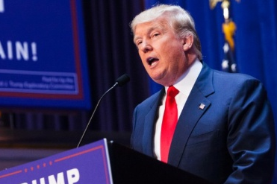
Donald Trump Calls for Total and Complete Ban of Muslims Entering the United States
https://www.youtube.com/watch?v=76An3ZxWNfk&feature=youtu.be
- According to Donald Trump, who is being oppressed?

- According to Donald Trump, who is/are the oppressor(s)?

- According to Donald Trump, what is the cause of this oppression?

- What is Donald Trump’s proposed solution?

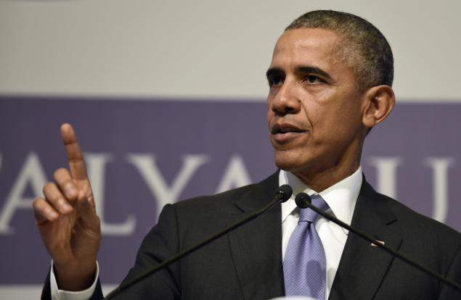
President Obama Says it is Shameful and Un-American to Suggest Rejecting Muslim Refugees
http://www.cnn.com/videos/tv/2015/12/09/new-paris-attacker-identified-bitterman-intv.cnn/video/playlists/paris-shootings/
- According to President Obama, who is being oppressed?

- According to President Obama, who is/are the oppressor(s)?

- According to President Obama, what is the cause of this oppression?

- What is President Obama’s proposed solution?

What other types of sources would you want to look at to further your understanding of Syrian refugees today?

Why is it important to consider situations from multiple perspectives?

Part Two: Analyzing Photographs to Detect Bias
Photographs can be used as political tools by deliberately portraying a single side of an issue. Conduct an internet search to find two photographs that express different views on the issue of Syrian refugees. Then analyze each photo to determine its meaning and purpose. Be prepared to share your photographs and explain your answers in class.
Photograph #1 | Photograph #2
Enter the URL address of the photo and its accompanying title or caption: | Enter the URL address of the photo and its accompanying title or caption:
Write a brief overview of the image. In one complete sentence, what is the image about? | Write a brief overview of the image. In one complete sentence, what is the image about?
How does the photo show support or opposition toward Syrian refugees? | How does the photo show support or opposition toward Syrian refugees?
How might this photograph be used as a political tool? | How might this photograph be used as a political tool?
What does this picture reveal about the photographer’s views on the issue of Syrian refugees? What ideas, arguments, or implications are they attempting to make? | What does this picture reveal about the photographer’s views on the issue of Syrian refugees? What ideas, arguments, or implications are they attempting to make?
Learning Targets
identify the political, economic, and cultural causes of oppression against minority groups (e.g. immigrants) and analyze how beliefs about civil and human rights vary among social, economic, and political groups.

